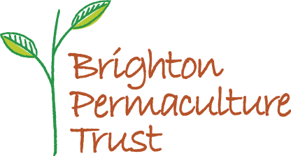

Brighton Permaculture Trust
Charitable company registered in England and Wales
Charity number 1150808
Company number 4072259

Application form for Project Development Worker – Brighton and Hove community orchards

Thank you for your interest in this post, we look forward to hearing from you.
Please fill in the personal details section and the three sections that follow, and email your completed application to bryn@brightonpermaculture.org.uk by 5pm Wednesday 5th August 2020.
Interviews for the post will be held Monday 17th August 2020

Personal details
Name:
Full postal address:
Email address:
Daytime phone number:

- Skills, abilities and experience
Describe your work history, skills and experience that you feel is relevant to this role.

- Why do you want this role?
Give some details about your current situation and motivation for applying for the work.

- Why do you feel you are suitable for this role?
Please use this section to demonstrate why you think you are suitable for the post.
Refer to the job description and give examples of previous experience where you have demonstrated similar skills and competencies.

Throughout the application please include all relevant information, whether obtained through formal employment or voluntary/leisure activities. Information can be presented in bullet points or sentences. Use as much space as you need, but be concise and accurate.

References
Please give the details of a reference that will be able to support your application.
Referee 1:
Name:

Relationship to you:
Postal address:
Email address:
Daytime phone number:

Please email your completed application to bryn@brightonpermaculture.org.uk by 5pm Wednesday 5th August 2020.

